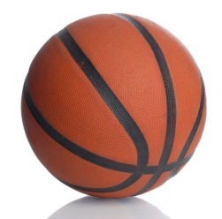Basketball Words
my do yes this
me could what get
were so one not
can did see would
them will like when
Take Home List #3
Goal: Read the words to me quickly three days in a row to move to the next set of ball words!

