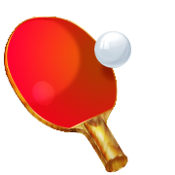Ping Pong Ball Words
soon has our warm
made find better ate
run only hold full
gave us buy those
open three funny done
Take Home List #9
Goal: Read the words to me quickly three days in a row to move to the next set of ball words!

